Marirose Tan
EDU Practicum 1 Lesson Plan
March 11, 2016

Chapter 16 Section 2 Russia and the Caucasus

Grade Level: 7th grade
Subject Area: Geography
Materials Needed: Lesson Plan, computer, powerpoint, projector screen, internet access, quizlet quiz, protector sheet paper, dry erase writing utensils, paper for students to take notes with, a timer

Standards:
Standard 2: Students understand important historical events
7.2.1 Identify major historical events and issues (e.g., conflicts and resolutions, natural resources) within regions of the world and their impact
Standard 4: Students understand the development, functions, and forms of various political institutions and the role of the citizen in government and society.
7.4.2 Explain how people create and change structures of power (e.g. force, elections, wars, reactions to economic conditions and natural disasters)
Standard 5: Students understand and apply concepts of geography
7.5.1 Identify current countries and principal physical features (e.g. ecosystems, mountain ranges, bodies of water) of the world.

Objectives:
Students will be able to:
- Show knowledge of geographical features of Russia and the Caucasus through a quizlet assessment
- Apply knowledge of previous lessons to this lesson (i.e. Vikings are from Scandinavia, Slavs were people in Eastern European countries)
- Express knowledge of the early history of Russia through the questions in the lesson plan
- Define the words, soviet and communism

Learning Activities:
5min | Current events
5min | Explain the activity:  Split up into different groups by row (i.e. 6 groups of 4)  Separate them into different parts of the room  Give them a different sheet of protector sheet paper and a dry-erase writing utensil  Only allowed to use teammates as sources to answer the question  Answers are shown only when the teacher gives the signal (5-10sec approx. time to decide – will be done using a timer)  Make sure that everyone in your group agrees with your answer  The group that answers correctly first gets a bonus point  Correct answers get a point.  If a group is not behaving, it will lose points.  I will be keeping track of scores on my protector sheet paper. (I might bring something with me for the winners on my last day in practicum )
10min | Review Activity  Generated by quizlet – multiple choice and true-false  Link: https://quizlet.com/_23n50h
20min | Have students get back to their rows  Have students get their books, last one in the row to get the books (5min including transition)  Section 2 – using Miss Ripplinger’s powerpoint (questions, information, and visuals will be used with the powerpoint to enhance the engagement)- (note to self: remember wait time)  Early History and Empire (8min)  - Vikings: Where are they from? What are they most known for doing? From Scandinavia called the Rus – founded Kievan Rus, a state (now Kiev , capital of Ukraine)  - Missionaries – Russian Orthodox – main religion from those who spoke Greek, it is a branch of the Eastern Orthodox Church – used Cyrillic (write/show name in Cyrillic) Russian - Русский  Used http://www.lexilogos.com/keyboard/russian.htm  - Mongols (have you heard of them before?) from Mongolia - known as Tartars, impacted European history greatly, especially Eastern Europe which we learned about last week  - Original people Slavs – we read about them last week (open the book to page 362, Section 3 of Ch. 15 and p.382, Section 2 of Ch. 16)  - Ivan III of Muscovy became Czar (what does it sound like?)  - Muscovy, Russian state became Russia; capital– Moscow  - Peter the Great and…Catherine the Great- one of the first great women rulers in her time – they both made Russia into a world power  WWI (7min)  - Pull up a picture of Anastasia’s family – Nicholas II (Do you know the story of Anastasia?)  - Mention Fiddler on the Roof  - Bolsheviks – Do you know what Communism means?  ”Simple Definition of communism  from http://www.merriam-webster.com/dictionary/communism  : a way of organizing a society in which the government owns the things that are used to make and transport products (such as land, oil, factories, ships, etc.) and there is no privately owned property” – basically everything is owned by everyone  - Russian Revolution took down the Czar  - Soviet Union (USSR) What does Soviet mean?  “ "Soviet" means "Council". It refers to "councils of workers and peasants (or soldiers)", which started organizing in cities and villages in the early twentieth century in close cooperation with Russian Communist organizations.” https://www.quora.com/What-does-Soviet-mean-in-the-term-Soviet-Union-How-are-Soviets-different-from-Russians  - Vladimir Lenin  Under Stalin – WWII (Do this part if more time is needed, 3min)  - Who was Joseph Stalin? Leader after Lenin, leader that allied the USSR with the Allied powers of WWII  - Government owned everything  - Those who spoke out were jailed, exiled, killed  - Gulags – can be termed as the Soviet ”Concentration Camps” in Siberia
2min | Announcements (what is due next week, what day the test is) and clean up

Assessment:
Participation during the Review activity, the Review activity, the participation with the for the questions asked during class

Reflection:
I was originally going to use the following activity. I wasn’t sure if it would engage the rest of the students who are not involved at a given time.
Explain the review activity: (“Around the World” review)
- Be prepared to move
- Have you ever played the basketball exercise called “Around the World?” (explain it) This will be similar.
- Two students will be chosen from each row to start off
- The two starting students will be given a question. Whoever answers the question correctly first stays standing and is pair with the next person in the row. The person answered incorrectly
- During this time, everyone else should get out a piece of paper – take notes on the answers given
The winner from each row will get a bonus question round of questioning (If it is a multiple row class)

Russian - Русский

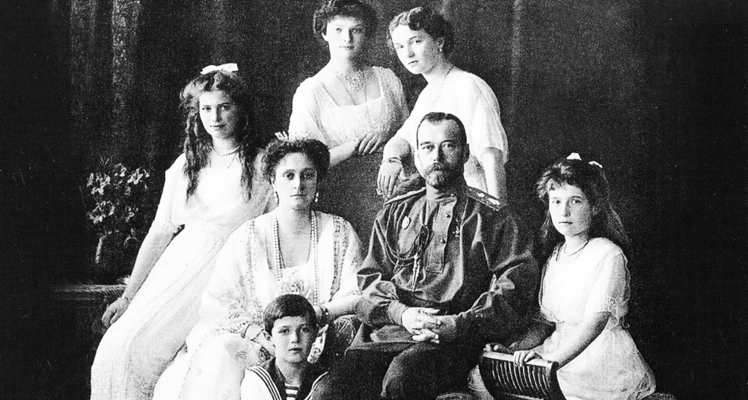

http://mojo.mk/uploads/main_article_photos/73616c4f00b30abe95af25baf6fc8727.jpg

Review Questions: (planning to be given using multiple choice on quizlet, planning more questions just in case this is not enough)
1. What stands on two continents at once? Ural Mountains (Europe-West; Asia- East)
2. What landmass is made up of two words? Eurasia (Europe and Asia)
3. What is the world’s LARGEST country? Russia (2x as large as USA)
4. Georgia, Armenia, and Azerbaijan make up what? The Caucasus (south of Russia)
5. What are the seas that are on the borders the Caucasus? The Black Sea and the Caspian Sea
6.What landform stretches across Europe into Russia? Northern European Plain
7.What is the name of the highest peak in Europe? Mount Elbrus
8.What is the vast area between the Ural Mountains and the Pacific Ocean? Siberia
9. What is the name of Russia’s capital? Moscow
10. How many lakes does Russia have? 200,000 lakes
11.What are three of the natural resources in Russia? Fertile soil, wood, metals
12. What is one of the most important rivers? Volga River
13. Why is the Volga River important? Forms the core of Russia’s river network
14. What body of water connects Russia to the Mediterranean Sea? Black Sea
15. What is the world’s largest inland sea? Caspian Sea
16. Coal, oil, hydroelectricity are resources for what in Russia and the Caucasus? Energy
17. Where do most Russians live? Northern European Plains
18. Where are the Caucasus Mountains found? Southern Russia
19. What is the climate of the Caucasus? Warm
20. What is Russia’s most important farming area called? Steppe
21. What covers ½ of Russia? Taiga
22. What is taiga made up of? A vast forest of evergreen trees
23. What is permanently frozen soil called? Permafrost
24. The Ob, the Yenisey, and the Lena are what physical geographic features? Rivers
25. If a river flows northward, is it beneficial for shipping in Russia?
26. The world’s deepest lake, Lake Baikal is found where? In Siberia
27. What is the longest river in Europe? Volga River
28. What can wood be used for? Buildings and paper
29. Are winters short in Russia? No
30. (bonus) What is a tundra? A cold desert

